THE UNIVERSITY OF AZAD JAMMU & KASHMIR, MUZAFFARABAD


COURSE TITLE | COMPUTER NETWORKS
COURSE CODE | CS-2203
TITLE | LAB 2
STUDENT NAME | HASEEB SHEIKH
STUDENT ROLL NUMBER | 2024-SE-31
INSTRUCTOR NAME | ENGR. DR. ASMA JAVED
SUBMISSION DATE | MARCH 07, 2026

DEPARTMENT OF SOFTWARE ENGINEERING
Computer Networking
Lab 2
Network Topology
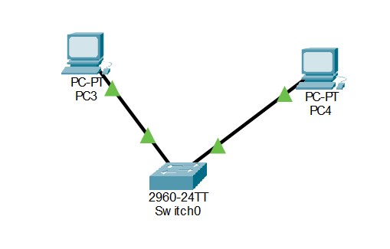
Screenshot:

Explanation: In this step, I created a simple Local Area Network (LAN) topology using Cisco Packet Tracer. I added two end devices (PCs) to the workspace and connected them to a central node, a switch, using copper straight-through cables. The green link lights indicate that the physical connections are active and the devices are ready to communicate within the same network.
IP Configuration
Screenshot:
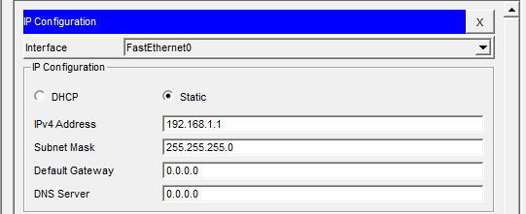

Explanation: To enable communication, a unique logical IP address was manually assigned to each PC. PC3 was configured with the static IP 192.168.1.1 and PC4 with 192.168.1.2 on the 192.168.1.0 network using a 255.255.255.0 subnet mask. A default gateway was not required because the devices are on the same local network, and no router is used to route traffic externally.
CLI Testing – PC 3
- Command: ipconfig
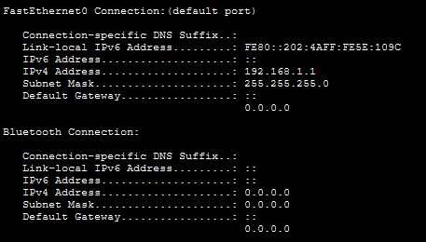

Explanation: The ipconfig command was executed in the Command Line Interface (CLI) to view the current IP configuration of the device. The output successfully verified that the static IP address and subnet mask entered in the graphical interface were properly applied to the PC's network adapter.
- Command: ping
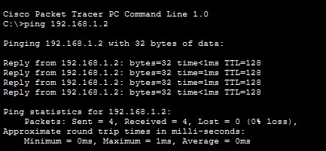

Explanation: The ping command was used to test network connectivity between PC3 and PC4. Receiving four consecutive "Reply from..." messages confirms that data packets are successfully being exchanged between the two nodes across the switch without any packet loss.
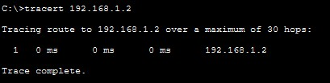
- Command: tracert

Explanation: The tracert command was run to display the specific path the packets took to reach the destination IP address. The output displays only a single hop because both PCs are directly connected to the same local switch, meaning the data does not need to traverse multiple routers to reach its target.
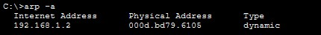
- Command: arp -a, netstat

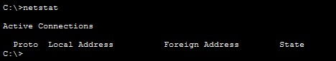

Explanation: The arp -a command successfully displayed the device's Address Resolution Protocol (ARP) table, which maps the known logical IP addresses to their corresponding physical MAC addresses. Additionally, the netstat command was executed to display active network connections and statistics for the system.
CLI Testing – PC 4
- Command: ipconfig
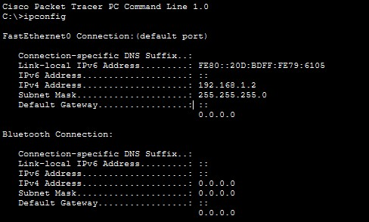

Explanation: The ipconfig command was executed in the Command Line Interface (CLI) to view the current IP configuration of the device. The output successfully verified that the static IP address and subnet mask entered in the graphical interface were properly applied to the PC's network adapter.
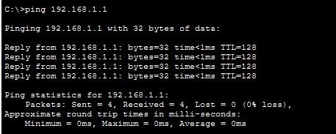
- Command: ping

Explanation: The ping command was used to test network connectivity between PC3 and PC4. Receiving four consecutive "Reply from..." messages confirms that data packets are successfully being exchanged between the two nodes across the switch without any packet loss.
- Command: tracert
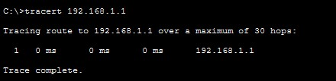
Explanation: The tracert command was run to display the specific path the packets took to reach the destination IP address. The output displays only a single hop because both PCs are directly connected to the same local switch, meaning the data does not need to traverse multiple routers to reach its target.
- Command: arp -a, netstat
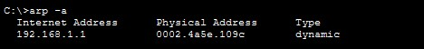
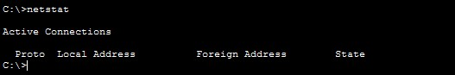

Explanation: The arp -a command successfully displayed the device's Address Resolution Protocol (ARP) table, which maps the known logical IP addresses to their corresponding physical MAC addresses. Additionally, the netstat command was executed to display active network connections and statistics for the system.

